Ideation Phase
Brainstorm & Idea Prioritization Template

Date | 05 Feb 2026
Team ID | LTVIP2026TMIDS80676
Project Name | FreelanceFinder: Discovering Opportunities, Unlocking Potential
Maximum Marks | 4 Marks

Brainstorm & Idea Prioritization Template:
Brainstorming provides a free and open environment that encourages everyone within a team to participate in the creative thinking process that leads to problem solving. Prioritizing volume over value, out-of-the-box ideas are welcome and built upon, and all participants are encouraged to collaborate, helping each other develop a rich amount of creative solutions.
Step-1: Gathering, Collaboration and Select the Problem Statement
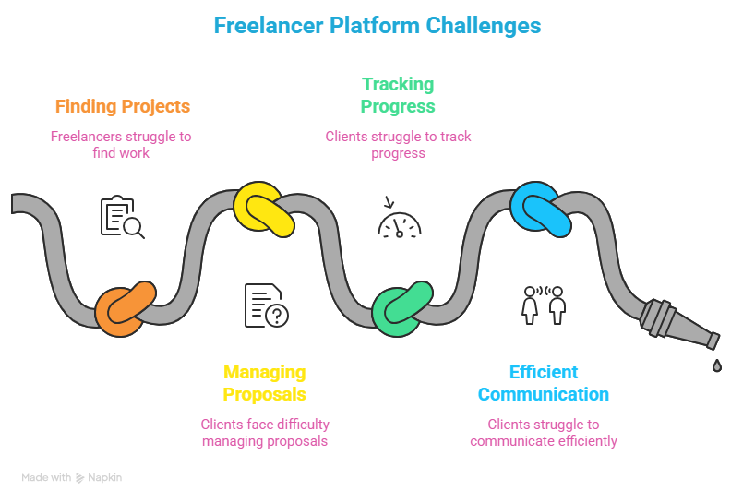

Many freelancers struggle to find reliable projects, while clients face difficulty managing proposals, tracking progress, and communicating efficiently. Existing platforms are often complex, expensive, or lack student-friendly features.
Selected Problem Statement:
Design and develop a secure MERN-based freelancing platform that simplifies project posting, proposal management, communication, and work submission within a single user-friendly system.

Step-2: Brainstorm, Idea Listing and Grouping
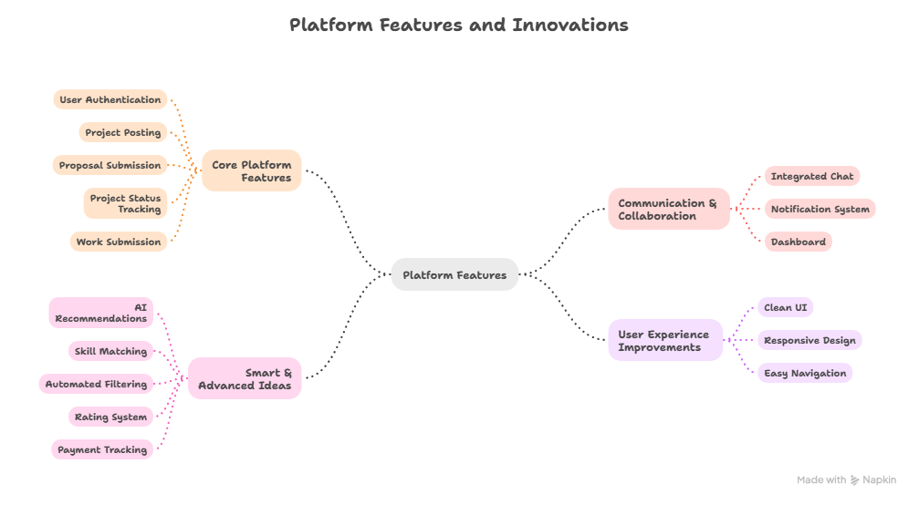

Step-3: Idea Prioritization
